Title of the contribution

Authors
Affiliations
Email

Keywords:
Abstract

References
Xyz, M. M. (xxxx)…..

Figures
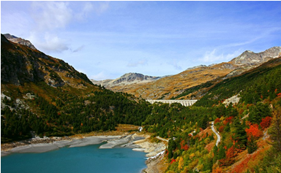
Figure 1 : Representation of reference, dynamic and yield surfaces

