Title of the contribution

Authors
Affiliations
Email

Keywords:
Abstract
This is a template for the extended abstracts submitted to the poster session. Extended abstracts are expected to be 1 or 2 pages long and should contain some Figure(s) and references.
When sending the abstract, please rename the file as
“Template_Abstract_ALERT-Geomaterials2023_SURNAME_OF_FIRST_AUTHOR.docx”
When sending your poster, please name your pdf file as
“ALERT_poster2023_ SURNAME_OF_FIRST_AUTHOR.pdf”
Many thanks for your contribution!
References
Xyz, M. M. (xxxx)…..

Figures
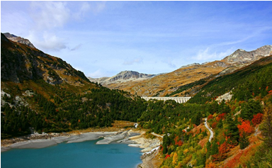
Figure 1 : Representation of reference, dynamic and yield surfaces

