Title of the contribution

***Authors***

*Affiliations*

*Email*

***Keywords***:

***Abstract***

This is a template for the extended abstracts submitted to the poster session. Extended abstracts are expected to be **1 or 2 pages long** and **should contain some Figure(s) and references**.

When sending the abstract, please rename the file as

“Abstract_ALERT-Geomaterials2025_SURNAME_OF_FIRST_AUTHOR.docx”

For the lightning sessions, you can send a single slide (in pdf format) to support your 1 min speech. Please name your slide.

“Slide_ALERT-Geomaterials2025_SURNAME_OF_FIRST_AUTHOR.pdf”

For eligible PhD students, if you wish to participate to the poster competition, please send your poster together with the abstract in pdf format, named as

“Poster_ALERT-Geomaterials2025_ SURNAME_OF_FIRST_AUTHOR.pdf”

Many thanks for your contribution!

***References***

Xyz, M. M. (xxxx)…..

***Figures***

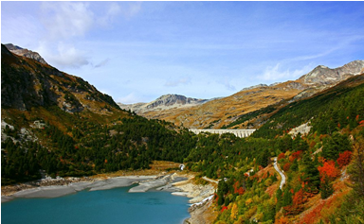

***Figure 1 :*** *Representation of reference, dynamic and yield surfaces*